Digital Circuit for Driving Vending Machine

___________________________________

A Mini-Project Report Presented to

The School of Engineering

Oral Roberts University

_________________________________________

In Partial Fulfillment

Of the Requirements for the Degree

Bachelor of Science

Electrical Engineering
_________________________________________

Mekhi Jalen Burns

John Mark Obura

April 30th, 2026

_________________________________________

Dr. Xiaomin Ma

2. Project Description and Problem Formulation

2.1 Project Description and Objectives
This project involves the design and implementation of a synchronous digital vending machine capable of dispensing candy upon receiving a total of 15 cents. The system accepts nickels (5 cents) and dimes (10 cents) as inputs and is designed to return change when the deposited amount exceeds the required value. Once the vending condition is satisfied, the machine dispenses candy and automatically resets to its initial state on the next clock cycle.
The primary objective of this project is to design a reliable and efficient sequential circuit using J-K flip-flops that models real-world vending machine behavior. The system is required to correctly track accumulated input values, generate appropriate outputs (candy and change), and maintain stable state transitions under clocked operation.
This project serves as a practical application for finite state machine (FSM) design, sequential logic, and hardware implementation. It benefits students by reinforcing key concepts in digital systems design, including state encoding, excitation table derivation, Karnaugh map simplification, and circuit realization. If applied on a wider scale, it also benefits vending machine makers. Additionally, the project demonstrates how theoretical digital logic principles are applied to solve real engineering problems in automated systems.

2.2 Problem Formulation
The vending machine is modeled as a synchronous finite state machine operating under a clock signal. The system tracks the total value of inserted coins and transitions between defined states based on the input received.

2.2.1System Functionality
The system performs the following functions:
- Accepts one coin at a time (either a nickel or a dime)
- Accumulates the total value of inserted coins
- Dispenses candy when the total reaches exactly 15 cents
- Dispenses candy and returns change when the total exceeds 15 cents
- Automatically resets to the starting state after dispensing
The system’s behavior is captured through a Moore finite state machine, where outputs depend only on the current state.

2.2.2Inputs and Outputs
The circuit is defined by the following inputs and outputs:

Inputs
- N (Nickel): Represents insertion of a 5-cent coin
- D (Dime): Represents insertion of a 10-cent coin
- Clock: Synchronizes all state transitions
- Reset (Clear'): Active-low signal used to initialize the system to the starting state
Only one coin input is valid at any given time, as specified in the project constraints.

Outputs
- Z (Candy Output): Indicates when candy is dispensed
- C (Change Output): Indicates when change is returned
From the design, candy is dispensed when the system reaches the appropriate output states, and change is produced only when the inserted amount exceeds the required value.

2.2.3 State Representation
The system is represented using five states corresponding to accumulated coin values and output conditions, as reflected in the design sketches :
- S0 (000): Initial state (0 cents)
- S1 (001): 5 cents inserted
- S2 (010): 10 cents inserted
- S3 (011): Candy dispensed (15 cents reached)
- S4 (100): Candy dispensed with change (20 cents reached)
After reaching either S3 or S4, the system transitions back to S0 on the next clock cycle.

2.3 Design Constraints
Several constraints were considered in the design:
- Only one coin can be inserted at a time
- The system must operate synchronously with a clock signal
- The design must use J-K flip-flops, as specified in the project requirements
- The number of flip-flops must be minimized (3 flip-flops used for 5 states)
- Invalid input combinations (such as inserting both coins simultaneously) must not disrupt system operation
- The circuit must be stable and free from unintended oscillations

2.4 Design Methodology and Components
The design follows a structured digital design methodology:
- State definition and encoding
- Finite State Machine (FSM) diagram development
- Construction of the state transition (excitation) table
- Derivation of J-K flip-flop input equations using Karnaugh maps
- Circuit implementation using logic gates and flip-flops
The primary hardware component used is the SN74LS76A dual J-K flip-flop, which provides clocked operation along with asynchronous preset and clear inputs. In this design, the preset inputs are held inactive, while the clear input is used for system reset.

2.4.1 Design Considerations and Challenges
During the design process, particular attention was given to ensuring correct state transitions and stable circuit behavior. Early implementations revealed that improper use of don’t-care conditions in Karnaugh maps led to incorrect logic simplifications, resulting in unintended toggling of flip-flops and unstable outputs.
This issue highlighted the importance of carefully selecting valid groupings in K-map simplification and ensuring that derived equations strictly preserve required state transitions. The final design resolves these issues by enforcing correct excitation conditions and avoiding overly aggressive simplifications.
The circuit was implemented using standard TTL integrated circuits. The main chip used for the state memory was the SN74LS76A dual J-K flip-flop, which provides two J-K flip-flops per chip. Since the vending machine requires three state bits, two SN74LS76A chips were used, giving a total of four available J-K flip-flops, with three used in the design.
Additional TTL logic gate chips were used to implement the Boolean equations for the J and K inputs and the output logic. These included:
- SN74LS76A: Dual J-K flip-flop used for state storage
- 7408: AND gates used to form product terms
- 74LS32: OR gates used to combine logic terms
- 7411: Three input AND gate to form product terms

2.4.2 Summary of Problem Scope
In conclusion, the project requires the development of a synchronous digital vending machine system that accurately models coin accumulation, output generation, and automatic reset behavior using J-K flip-flops.

3. Design and Possible Approaches

3.1 Possible Design Approaches and Selected Approach
There are two main approaches that can be used to design this vending machine: a Mealy machine or a Moore machine. In a Mealy machine, the outputs depend on both the present state and the current inputs. This can reduce the number of states, but it can also make the output behavior more sensitive to input changes. In a Moore machine, the outputs depend only on the present state. This usually requires more states, but it makes the outputs more stable and easier to observe in hardware.
For this project, a Moore finite state machine was selected. This approach was chosen because the candy output and change output are easier to control when they are tied directly to specific output states. Since the project was implemented physically using clocked J-K flip-flops, output stability was important. The Moore design allowed the system to assert the candy and change outputs only when the machine entered the correct dispensing states.
The circuit was designed using J-K flip-flops, as allowed by the project requirements, which specify that the circuit may be designed using either D flip-flops or J-K flip-flops. J-K flip-flops were chosen because they provide flexible set, reset, hold, and toggle behavior, making them suitable for sequential logic implementation. Additionally, using J-K flip flops ensures simpler next state logic to be implemented. The SN74LS76A dual J-K flip-flop was used for state memory.

3.2 Definition of States and Digital Variables
The vending machine accepts two-coin inputs: a nickel input, N, representing 5 cents, and a dime input, D, representing 10 cents. Only one coin is accepted at one time, so the input combination N = 1 and D = 1 is treated as invalid.
The system requires five states to represent the accumulation of money and the dispensing conditions:
Table 1: States, encodings, Physical meanings and outputs
State | Encoding  $Q_{2}, Q_{1, }Q_{0}$ | Physical Meaning | Output (Z) | Output (C)
S0 | 000 | 0 cents inserted / starting state | 0 | 0
S1 | 001 | 5 cents inserted | 0 | 0
S2 | 010 | 10 cents inserted | 0 | 0
S3 | 011 | 15 cents reached; candy dispensed | 1 | 0
S4 | 100 | 20 cents reached; candy dispensed with change | 1 | 1

The state variables are:
- ($Q_{2}$): Most significant state bit
- ($Q_{0}$): Least significant state bit
The outputs are:
- (Z): Candy release output
- (C): Change output
Since this is a Moore machine, (Z) and (C) depend only on the present state, not directly on the input coin.

3.3 Finite State Machine Diagram Description
To really understand how this machine works, I had to sketch out the state transition diagram shown in Figure 1.
Figure 1: State transition diagram
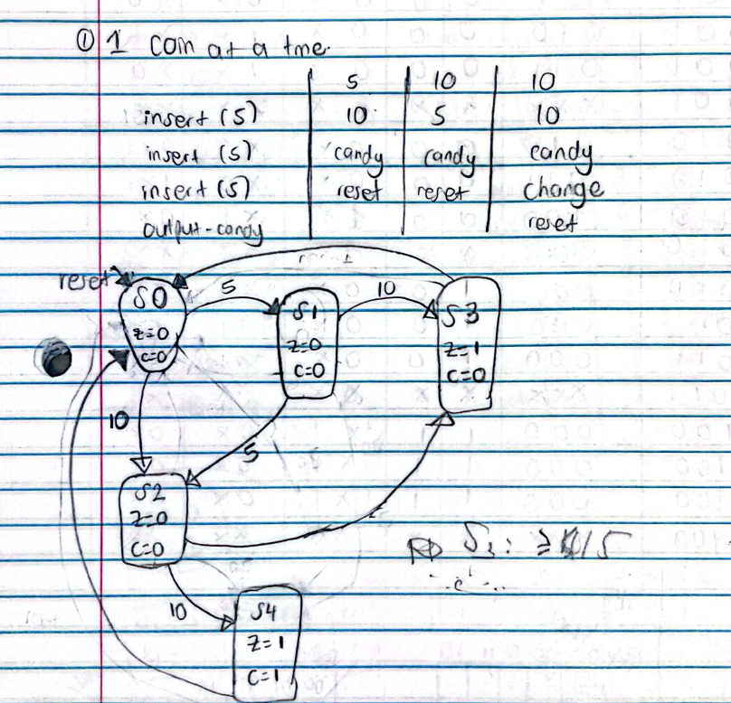
The FSM begins in state S0, representing 0 cents inserted. If a nickel is inserted, the machine moves to S1. If a dime is inserted, the machine moves to S2.
From S1, inserting another nickel moves the machine to S2, since the total becomes 10 cents. Inserting a dime from S1 brings the total to 15 cents, so the machine moves to S3, where candy is dispensed.
From S2, inserting a nickel brings the total to 15 cents, so the machine moves to S3. Inserting a dime from S2 brings the total to 20 cents, so the machine moves to S4, where candy is dispensed and change is given.
After entering either S3 or S4, the machine returns to S0 on the next clock cycle. This satisfies the project requirement that the vending machine reset itself to the starting state after dispensing candy.
For no coin input, the machine remains in the same accumulation state until a valid coin is inserted.

3.4 State Transition and J-K Excitation Table
Table 2: J-K excitation table
Present (Q) | Next ($Q^{+}$) | J | K
0 | 0 | 0 | X
0 | 1 | 1 | X
1 | 0 | X | 1
1 | 1 | X | 0
Using this excitation table, the FSM transitions were converted into the following J-K excitation table.
The invalid input case (N = 1, D = 1) was treated as a don’t-care condition because the project states that only one coin can be accepted at a time.
Figure 2: State transition table and J-K excitation table
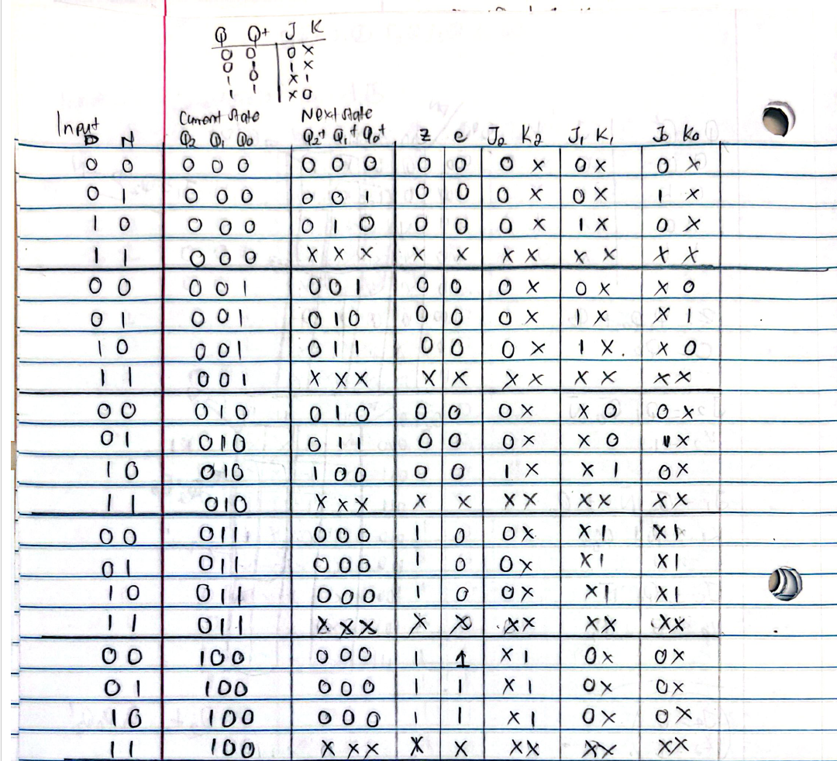

3.5 Simplified J-K Flip-Flop Input Equations
From the excitation table, Karnaugh maps were used to simplify the J-K input equations. Care was taken not to overuse don’t-care conditions, since doing so can create unstable or unintended transitions in the physical circuit.
Figure 3: Simplifying next state logic and outputs with K-Maps
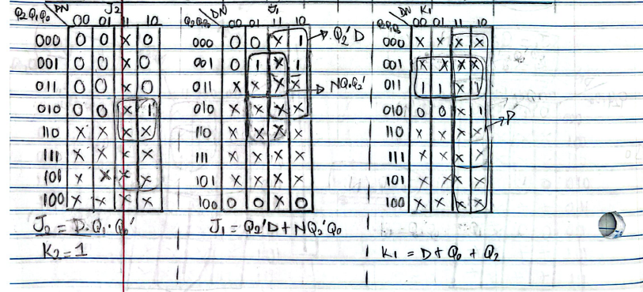
Figure 3.1: Simplifying next state logic and outputs with K-Maps

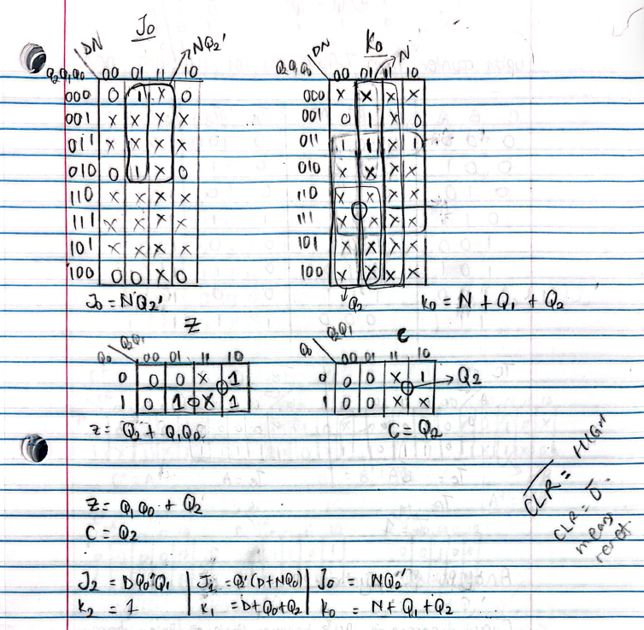
The final corrected J-K input equations are:
$J_{2}= DQ_{1}Q_{0}^{'}$ $J_{1}= Q_{2}^{'}\left(D + NQ_{0}\right)$ $J_{0}= NQ_{2}^{'}$
$K_{2}= 1$ $K_{1}= D+Q_{0}+Q_{2}$ $K_{0}=N+Q_{1}+Q_{2}$
These equations ensure that the flip-flops transition only when required by the FSM. For example, ($J_{2}$ ) is asserted only when the machine is in state S2 and receives a dime, causing the transition from 10 cents to the candy-with-change state S4.

3.6 Output Equations
Since the circuit is a Moore machine, the output depends only on the present state.
Candy is dispensed in states S3 and S4, therefore, based on Figure 3 and 3.1, the outputs are:
$$Z =Q_{2}+Q_{1}Q_{0}$$
Change is given only state 4, that is, only when $Q_{2}$ is high.
$$C =Q_{2}$$

3.7 Circuit Diagram Description
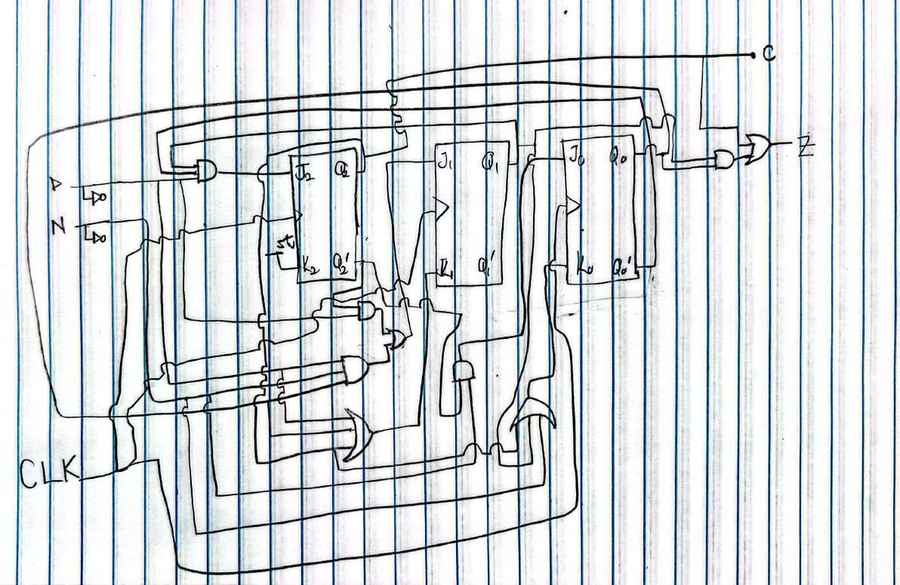
Figure 4: Circuit Diagram
The circuit consists of three J-K flip-flops used to store the present state bits. All three flip-flops are driven by the same clock signal, so that state changes occur synchronously.
The combinational logic network takes the present state outputs, along with the coin inputs (N) and (D), and generates the six flip-flop input signals. These signals are connected to the corresponding J and K inputs of the three flip-flops. The output logic network uses the present state bits to generate (Z) and (C).
The reset function is implemented using the active-low clear inputs of the J-K flip-flops. During normal operation, clear inputs are held high. When reset is activated, the clear inputs are pulled low, forcing all flip-flop outputs to zero and returning the machine to state S0. This reset mechanism implemented on the breadboard was used to ensure that the machine always starts at the default S0 during startup and not enter any other unwanted states due to many don’t cares in the project.

3.8 Design Reflection
During implementation, an early version of the circuit produced unstable behavior because some don’t-care conditions were grouped too aggressively in the Karnaugh maps. This caused certain flip-flop input equations to assert signals in states where they should not have been active. The corrected design avoids this issue by ensuring that each J and K input matches the required state transitions from the excitation table.
The final circuit therefore satisfies the intended vending-machine behavior: it accepts nickels and dimes, tracks the accumulated amount, dispenses candy at 15 cents, returns change when the total exceeds 15 cents, and returns to the starting state after dispensing.

4. Circuit Implementation and Results
Figure 5: Implementation of circuit on breadboard
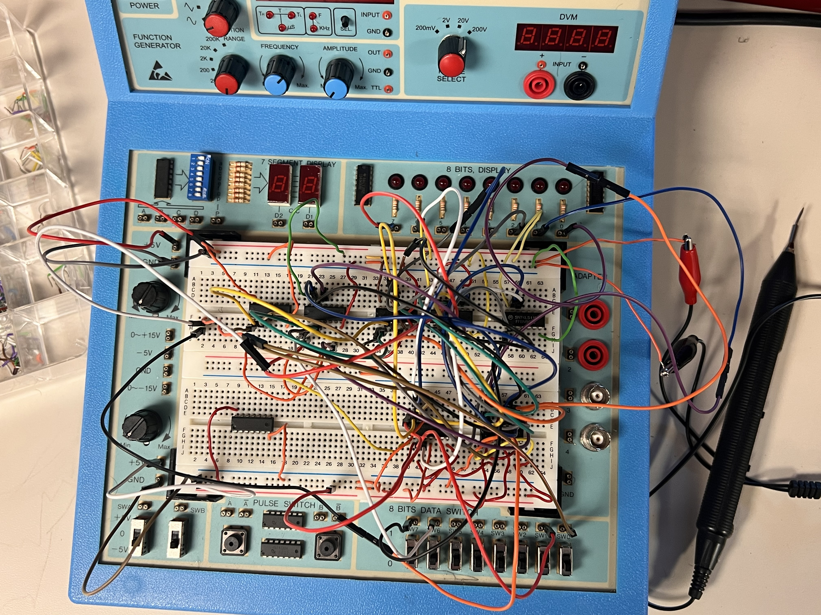

4.1 Circuit Implementation
The designed vending machine circuit was implemented on a breadboard using standard TTL components. The circuit was constructed directly from the derived logic equations and verified state transition behavior. Three J-K flip-flops were used to store the system's state variables, and combinational logic gates were used to generate the corresponding J and K inputs based on the present state and coin inputs.
The coin inputs, nickel (N) and dime (D), were implemented using manual input switches to simulate coin insertion. A clock signal was provided to ensure synchronous operation of the system. The outputs Z (candy release) and C (change) were connected to LEDs for clear visual indication of system behavior.
The asynchronous clear inputs of the J-K flip-flops were connected to a reset mechanism, allowing the system to be initialized to the starting state S0. During normal operation, clear and preset inputs were held HIGH on the J-K flip flop chips to allow proper state transitions.
The completed circuit successfully reflected the intended FSM design. A physical breadboard implementation was constructed (Figure 5), with careful attention to proper wiring, stable power connections, and correct placement of logic components.

4.2 Definition of Completeness
The circuit was considered complete when it satisfied all functional requirements of the vending machine system as defined in the project specification. Specifically, completeness was defined by the following conditions:
- The system correctly transitions between all defined states based on coin inputs.
- The machine accurately accumulates coin values (5¢ and 10¢).
- The output Z is asserted only when the total reaches 15 cents or more.
- The output C is asserted only when the inserted amount exceeds 15 cents.
- The system returns to the initial state after dispensing candy.
- No unintended or unstable state transitions occur during operation.
- The circuit operates consistently across repeated test cycles.
When all of the above conditions were met during testing, the implementation was considered fully complete.

4.3 Design Constraints
Several constraints influenced the design and implementation of the vending machine circuit:
- Flip-Flop Constraint: In the design, we limit ourselves to using J-K flip-flops. A total of three flip-flops were used to represent five distinct states, which is the minimum number required for the chosen state encoding.
- Gate Count Constraint: The number of logic gates was minimized through careful simplification of Boolean expressions using Karnaugh maps. This ensured efficient and practical hardware implementation.
- Input Constraint: Only one coin input could be active at a time, as specified in the project requirements. The combination N = 1 and D=1 was treated as invalid.
- Hardware Constraint: The design was implemented using available TTL components, including the SN74LS76A J-K flip-flop AND gates and OR gates.
- Timing Constraint: The circuit operates synchronously, so all state transitions must occur only on the clock edge. Inputs were stabilized before clock pulses to avoid unpredictable behavior.
- Stability Constraint: Special care was taken during logic simplification to avoid incorrect grouping of don’t-care conditions, which could lead to unintended toggling or unstable outputs.

4.4 Testing Procedure
A systematic testing process was used to verify that the circuit met the design expectations.

Test Plan
The circuit was tested by applying all valid input combinations and observing the resulting state transitions and outputs. As observed in Figure 5, the current state was also monitored by connecting $Q_{2},Q_{1} and Q_{0}$ to the light to monitor the transition of state with each input. The following test scenarios were performed:
- Initial State Verification
  - Reset the system and confirm that the state is S0; that is the current state lights are all off. Reset was acquired by connecting the CLR’ input to a switch and setting it to low.
  - Verify that outputs Z=0 and C=0.
- Single Coin Insertion
  - Insert a nickel and verify transition to S1, current state lights should show 001.
  - Insert a dime and verify transition to S2; current state lights should show 010.
- Sequential Coin Testing
  - Insert two nickels and confirm transition to S2; current state light should still show 010.
  - Insert a nickel followed by a dime and confirm transition to S3; current state lights should show 011.
  - Insert a dime followed by a nickel and confirm transition to S3; current state lights should show 011.
- Dispensing Behavior
  - Verify that when the system reaches S3, the candy output Z is asserted and C is low.
  - Verify that when the system reaches S4 (current state lights should show 100), both candy Z and change C are asserted.
- Reset Behavior
  - Confirm that after reaching S3 or S4, the system returns to S0 on the next clock cycle.
- Repeatability
  - Repeat all tests multiple times to ensure consistent and stable operation.

4.5 Results
The implemented circuit successfully met all functional requirements. The state transitions occurred as expected, and the outputs correctly reflected the vending machine behavior. Candy was dispensed at the appropriate time, change was returned when necessary, and the system consistently reset to the starting state after dispensing.
Initial testing revealed instability due to incorrect logic simplification, which resulted in unintended toggling of flip-flops. This issue was traced to improper use of don’t-care conditions during Karnaugh map grouping. After correcting the logic equations, the circuit operated reliably and produced stable outputs.
The final implementation demonstrated correct operation under all tested conditions, confirming that the design was successful and complete.

5. Summary and Reflection

5.1 Personal Learning and Benefits
This project provided a strong practical understanding of sequential circuit design and reinforced key concepts learned in class. Through the design and implementation of the vending machine, I developed a deeper understanding of finite state machines, state encoding, and the behavior of J-K flip-flops in a real hardware environment.
One of the most valuable aspects of this project was seeing how theoretical design translates into physical implementation. Concepts such as excitation tables, Karnaugh map simplification, and clocked state transitions became much clearer once they were applied on a breadboard. This project also strengthened my ability to debug digital circuits and analyze system behavior systematically.
Additionally, the project improved my problem-solving skills, patience, and attention to detail, which are essential in digital systems design.

5.2 Challenges Encountered
Several challenges were encountered during the design, implementation, and testing phases.
The most significant challenge was related to the simplification of logic equations using Karnaugh maps. Initially, don’t-care conditions were used too aggressively during grouping. While this simplified the equations, it introduced unintended behavior in the circuit. Specifically, some flip-flop inputs were activated in states where they should not have been, leading to unstable transitions.
This resulted in the circuit exhibiting incorrect behavior, such as outputs toggling unexpectedly with each clock pulse rather than following the intended state sequence.
Another challenge was ensuring correct interpretation of the J-K excitation table. Since each flip-flop must transition according to specific conditions, any small mistake in assigning J or K values led to incorrect state changes in the hardware.
Additionally, wiring the circuit on the breadboard requires careful attention. Managing multiple connections, ensuring proper grounding, and maintaining stable inputs were important to avoid noise and unintended signals. I recall on my first attempt; I connected all J-K flip flops’ CLR’ and PRE’ inputs to low which caused the flip-flops to be non-functional.

5.3 Resolution and Improvements
The issues encountered during implementation were resolved through systematic debugging and verification.
The logic equations were re-examined by returning to the state transition table and carefully re-evaluating the Karnaugh maps. Instead of maximizing simplification, emphasis was placed on preserving correct state transitions. This ensured that each J and K input was only activated when required.
The excitation table was also reviewed step-by-step to confirm that each flip-flop transition matched the intended behavior. This helped eliminate errors that caused unintended toggling.
Testing was repeated for all input combinations, and corrections were made until the circuit behaved consistently and correctly under all conditions. Once the corrected equations were implemented, the circuit operated reliably and matched the expected vending machine’s behavior.

5.4 Laboratory and Team Contribution
The project was completed with strong collaboration and effort within the laboratory environment. Extended time was spent in the lab to ensure the circuit was functioning correctly. In one instance, Jake, Tesfaye, and I worked continuously from approximately 2:40 PM until 10:00 PM to debug and finalize the design. This time was used to carefully test the circuit, identify issues, and implement corrections.
The laboratory space provided the necessary tools and environment for building and testing the circuit. Access to components, breadboards, and test equipment was essential in completing the implementation successfully.
Discussions and collaboration within the group were also valuable, as they allowed different perspectives to be considered when troubleshooting issues. This contributed to a more thorough and accurate final design.

5.5 Final Reflection
Overall, this project was a valuable learning experience that highlighted the importance of precision in digital design. It demonstrated that while simplification is important, correctness and stability must always be prioritized.
The final circuit successfully met all design requirements, and the debugging process provided important insights into how digital systems behave in real hardware. The experience gained from this project will be useful in future work involving sequential logic design and hardware implementation.

